LANDIS-II

Forest Products Sector Output Extension

Version 0.1

User’s Guide

Caren C. Dymond and Sarah Beukema

Last Revised: April 28, 2024

# 

## The Extension

This document describes the Forest Products Sector (FPS) extension for the LANDIS-II model. This version is designed to work with output from the Forest Carbon Succession extension (ForCS, Dymond et al, 2021). For information about the LANDIS-II model and its core concepts including succession, see the LANDIS-II Conceptual Model Description.

This model is designed to take the carbon that is harvested by the ForCS model, and track it through several processing steps. Each step moves carbon between different product or waste pools and reports output. The extension allows users to see how much C is stored in forest products over time, as well as the resulting emissions.

While the number of processing steps is fixed, the complexity and the details in each is largely user defined and will be described below. This extension is compatible with Intergovernmental Panel on Climate Change (IPCC) accounting and can be adapted to IPCC default approaches or the methods used by the US Forest Service and Dymond (2012).

### Overview

This guide provides examples for convenience. All pools, transfers, “markets” and emissions are user defined within the broader framework allowing extensive customization (Figures 1, 2 and 3).

The FPS extension reads the output from the ForCS model and tracks the C through a number of steps. At each step there are different pools (pale ovals) and parameters (dark rectangles) that describe how to move between one set of pools and the next.

In general terms, the first step reads the harvest stream and divides into mills that produce primary products such as lumber and chips which are sent to different markets (Figure 1). These are then processed into secondary products such as houses and paper. These are eventually sent into ‘retirement’ (Figure 2). Once disposed of the C decays or is burned and is emitted (Figure 3). Landfill gas management effects are available as well. Substitution calculations can also be included (Figure 4).

Details will be given in Chapter 2 about working with the input tables, but it is important to note here that the “Name” column is provided to make the table more readable for humans, and any codes >1000 are pre-defined as they have specific processing steps.

The example simulation unit is a square 100 metres long on each side. Carbon in the input files (see Section 4) is in units of gC/m2 and carbon in the output files is expressed in unites of metric tons C/ha. Output is produced for each annual step of the model.

If you are not using LANDIS-II, to use the FPS Extension, you will need to obtain and install a copy of the DotNet 2.2 Runtime software, currently released as version 2.2.8 and found at

<https://dotnet>.microsoft.com/en-us/download/dotnet/2.2

After downloading the FPS, model users will need to create a configuration text file. Two examples are provided but are not providing default values. One example provides a structure similar to the US Forest Service and Dymond 2012 approach, the other follows the IPCC approach. Details are provided in Chapter 2.

### Harvest To Primary Products

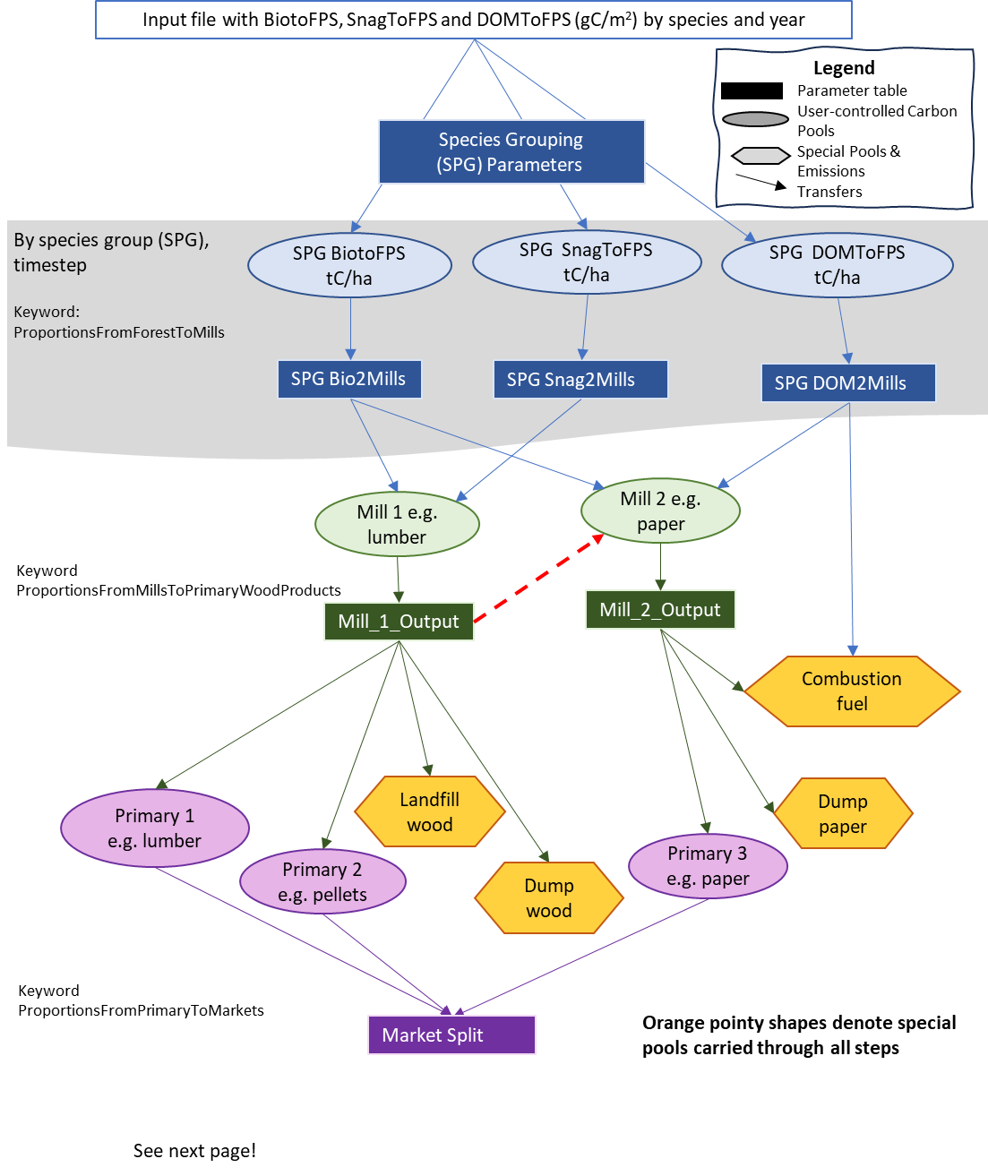

*Figure 1: From forests to markets. Schematic of an example of how the first part of the Forest Products Sector Output extension can be used. Orange shapes with points on either side denote special pre-defined pools carried through all steps. See Chapter 2 for more information on keywords.*

The first step of the model is to read the output from the ForCS model (Figure 1). The model reads the raw output files log_FluxBio.csv and log_FluxDom.csv. These contain the output of the amount of Biomass, Snag and Dead Organic Matter (DOM) C that is harvested, by species. The user can group these species into units that are most likely processed together. For example, users could define a group “All” or two groups: “Hardwood” and “Softwood” or keep two types of trees separate.

*Note: In future versions, users will be able to give the model the management unit map so that this first processing step can include a dependence on location.*

The processing of the harvest is defined in a table in which the user states, for each species group and harvest type, how the C is divided into different products. Users can define any number of different products, and both the mills, and the proportions that go into each, can change over time.

### Mills to Primary Wood Products

At the end of the previous step, the C had been transferred to user-defined mills. In this step, the user defines what happens in each of these mills: e.g. how the C is processed into lumber, chips, panels, etc. The user must create at least one destination for the carbon in each mill that was defined in the previous step.

One feature of this step, is that one mill can send material to another mill to simulate chips going from a plywood mill to a paper mill, for example.

### Primary Products to Markets

The model then provides the opportunity to move the primary products to different markets. Again, the “market” can be defined how the user wants, whether it is by province, state, region, country, or not relevant. The parameters for most later processing steps are stratified by market, so it makes sense to define the market to be at the level at which there are differences in processing or storage, or the level at which reporting is important. For example, if one region mostly processes lumber into building material, and another into pallets, the regional difference is important. Alternatively, if regions process identically, but you want to track what is happening in the regions separately, then regions should also be used. However, markets do not affect landfill and dump parameters in this version.

### Primary Products to Secondary Products

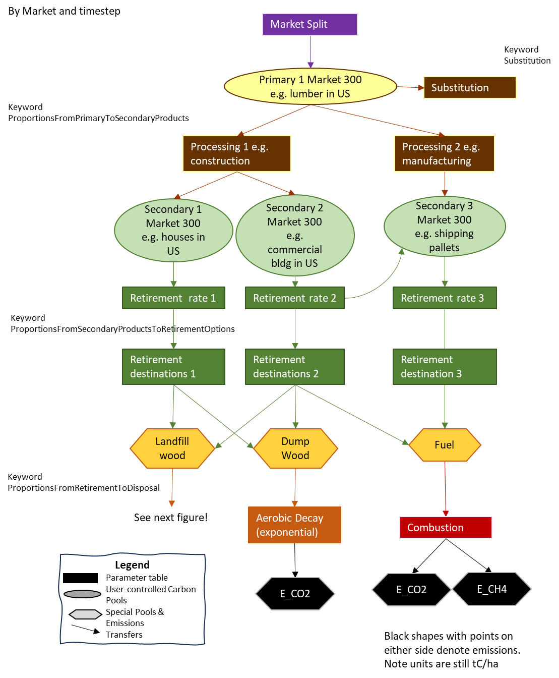

*Figure 2: From market split to disposal including substitution, aerobic decay and combustion. Schematic of an example of application of the second part of the Forest Products Sector Output extension. Orange shapes with points on either side denote special pre-defined pools carried through all steps and do not vary by market. Black shapes denote emissions although they are tracked cumulatively like another pool. Units are still tC/ha.*

There are two parts to setting up this step. The first part is very like the previous steps. Primary products are divided into secondary products by defining the parameters by time, and primary product (Figure 2). Because the previous step added the primary products to different markets, the parameters can be further refined by market.

The second part of this step defines the rate at which these secondary products will move out of the product pool over time. Users select a decay function and provide applicable parameters. The functions are:

* Instant, no parameters (e.g., Fuel)
* Exponential, with 1 parameter defining the half-life

### Secondary Product Retirement

The previous step defined *how* or the rate at which C will be removed from the secondary products pools, i.e., using the given decay function and parameters. This step define *where* the C ends up once leaving the pool.

The table is much like the others. Proportions are defined for each combination of market, product and destination. Note that recycling is included here since a secondary product can become the same or another secondary product.

Also note that the retirement pools are all predefined. Users can define the proportions, and whether or not they use a pool, but not how they are processed. A list of these definitions is in Table 1.

Table 1. Special predefined pools and codes.

|  |  |  |
| --- | --- | --- |
| **Fixed Code** | **Description (can be changed by user)** | **Comment** |
| 1000 | LandfillWood | Will be split into degradable and non-degradable components |
| 1001 | DumpWood |  |
| 1002 | CombustionFuel | Used for burning and bioenergy in forest sector |
| 1003 | DumpPaper |  |
| 1004 | LandfillPaper | Will be split into degradable and non-degradable components |
| 1005 | Fuel | Used for burning and bioenergy outside of forest sector |
| 1009 | DegradeableLandfillWood | The amount of LandfillWood that is subject to decay |
| 1010 | DegradeableLandfillPaper | The amount of LandfillPaper that is subject to decay |
| 1500 | Anaerobic | Anaerobic decay pathway |
| 1511 | Aerobic | Aerobic decay pathway |
| 2006 | E_CO2 | end point emissions in the form of CO2 |
| 2007 | E_CH4 | end point emissions in the form of CH4 |
| 2008 | PotentialCH4 | CH4 produced through anaerobic decay that, depending on configuration may be released as an end point emission or may be treated by landfill gas management and oxidation |
| 2999 | AerobicCO2 | CO2 emitted through aerobic respiration |

### Disposal

At the end of the previous step, the C is mostly in special pools such as fuel, dumps, or landfills (Figure 3). Because there are different pathways for the carbon that are all handled in one table, this is the most complicated table to understand and to parameterize.

There are three different options for what happens to these special pools (Table 1).

1. The pool immediately and entirely transforms to gasses. Examples of this would be for fuel or combustible fuel. The definition for this case is like most of the other tables: the destination gas, and the proportion of the material that goes to the gas.
2. The entire pool follows anaerobic or aerobic decay. An example would be DumpPaper or DumpWood. In this case, only the type of decay and the half-life of the pool are defined by the user.
3. The pool is partially decayed and partially transferred to another pool. In this case, the user will define the proportion that goes to the other pool (as in type 1) as well as the decay type and half-life that new pool. For example, LandfillWood will in part go to a degradable landfill wood pool. This pool will then decay using anaerobic decay with a half-life.

### Respiration Rules & Landfill Gas Management

There are 2 predefined sets of respiration rules. Users should note that the FPS extension does not currently recognize market-specific respiration, and the respiration rules are applied identically across all markets. Users may have to weight respiration parameters based on the data available to their market context and the possible of mix of landfills with and without LFGM.

* Aerobic (1511)
  + The portion of DumpWood and DumpPaper that is decayed goes to E_CO2. .
* Anaerobic (1500)
  + With the LandfillWood and LandfillPaper pools, 50% decays to E_CO2 and 50% to PotentialCH4.
  + Users can also define the oxidation efficiency, which represents the proportion of PotentialCH4 that is converted to CO2 as it passes through the landfill cap. An oxidation efficiency of 1.0 will convert 100% of potential CH4 to CO2.
  + Besides defining the oxidation efficiency, users can further define the fate of intermediate methane as it is handled by landfill gas management systems. The model then calculates the final emissions as:
    - E_CO2 = 50% of anaerobic decay +
      * PotentialCH4 * ProportionofLandfillsWithLGM * CaptureEfficiency +
      * (PotentialCH4 - PotentialCH4 * ProportionofLandfillsWithLGM * CaptureEfficiency) * Oxidation)
    - E_CH4 = the remainder.
  + NOTE!! ALTHOUGH EMISSIONS ARE CALLED E_CO2 AND E_CH4 THEY ARE CUMULATIVE AND IN UNITS OF tC/ha.

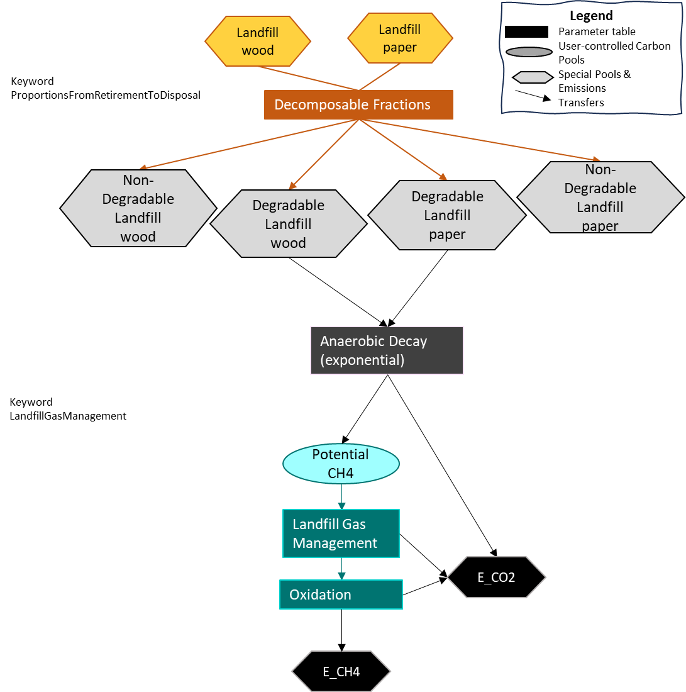

*Figure 3. Landfill emissions. Schematic of the third part of the Forest Products Sector Output extension. Orange shapes with points on either side denote special pre-defined pools carried through all steps and do not vary by market. Black shapes denote emissions although they are tracked cumulatively like another pool. Units are still tC/ha.*

### Substitution

Substitution does not affect the distribution of C in pools. It is a basic calculation to provide a sense of the substitution effects, i.e. the CO2e benefit if the total harvest was used instead of higher global warming potential products.

For each market and primary product, users can define two values: a substitution ratio and a displacement factor. The ratio represents the proportion of the market where consumers are using wood to replace higher Global Warming Potential products. The typical Life Cycle Assessment or mitigation study assumes 1.0. The displacement factor is the impact of the use of wood instead of other products. The total substitution impact is calculated as:

C in PrimaryPool * SubstitutionRatio * DisplacementFactor

### References

Dymond, C.C., 2012. Forest carbon in North America: annual storage and emissions from British Columbia’s harvest, 1965–2065. Carbon Balance and Management, 7(1), pp.1-20.

Dymond, C.C., Beukema, S, and Scheller, R.M. 2021. Landis-II Forest Carbon Succession Extension Version 3.1. (36pp)

Marland, E.S., Stellar, K. and Marland, G.H., 2010. A distributed approach to accounting for carbon in wood products. Mitigation and Adaptation Strategies for Global Change, 15, pp.71-91.

### Acknowledgments

Funding for the development of Forest Product Sector Output extension was provided by the British Columbia Ministry of Forests.

## Main Input Configuration File

Nearly all the input parameters for this extension are specified in one main input file. This text file must comply with the general format requirements described in Section 3.1 Text Input Files in the LANDIS-II Model User Guide.

Note that the “Name” column is provided to make the table more readable for humans, and any codes>1000 are pre-defined as they have specific processing steps.

TimeStart – the first column indicates when the parameters in the row should start being used. They will continue to be used until a new TimeStart is provided. This allows dynamic parameterization.

### Header

LandisData This parameter’s value must be "FPS".

CellLength The length in meters of a square simulation cell (pixel). Will be used in the future to convert to tC absolute value from g C/m2 ForCS default.

YearsPostHarvest The number of years past the last harvest in the input file to simulate. Value: >0. Units: years.

### Input Files

HarvestFileLive "log_FluxBio.csv"

HarvestFileDOM "log_fluxDOM.csv"

ManagementUnits "manunits.gis"

### Input Files

OutputInterval How frequently the output will be written. Minimum 1, must be integer.

### Species Group Table

The next row must contain the words “SpeciesGroupTable”.

The lines afterwards give a list of the species, a number for the group, and the name of the group. Use the word “all” to mean all species, or individual species if grouping them more finely. (We’ve not tested with more than 3 groups).

SpeciesGroupTable

>>Species Group GroupName

>>----------------------------------------------

pinubank 90 softwood

querelli 91 hardwood

pinuresin 90 softwood

### Forest to Mills

This table contains the information about dividing up the harvest to different primary mills.

The words “ProportionsFromForestToMills” must be prior to the table.

>>

>>Time Management Species Pool MillCode MillName MUSPG_2Mills_X

>> Start UnitCode Group

>>----------------------------------------------

0 1 90 BioToFPS 1 SoftwoodLumberMill 0.5

0 1 90 BioToFPS 2 ChipMill 0

0 1 90 BioToFPS 3 SoftwoodPlywoodMill 0.2

0 1 90 BioToFPS 4 OSBMill 0.1

### Mill To Primary

This table contains the information about how mills become primary products. In this table, the MillCodes are those that were defined in the previous table. Proportions must sum to 1 for combinations of time and mill.

The words “ProportionsFromMillsToPrimaryWoodProducts” must be prior to the table.

>>Time Mill Mill PrimaryOutput PrimaryOutput MillOutput

>> Start Code Name Code Name Proportions

>>-----------------------------------------------------------------------------------------------------------

0 1 LumberMill 104 Lumber 0.5

0 1 LumberMill 105 Chips 0.2

0 1 LumberMill 1000 LandfillWood 0.1

0 1 LumberMill 1001 DumpWood 0.1

0 1 LumberMill 1002 CombustionFuel 0.1

0 2 ChipMill 105 Chips 0.7

0 2 ChipMill 1001 DumpWood 0.1

0 2 ChipMill 1002 CombustionFuel 0.2

### Primary products to markets

This table gives the proportions of how primary products are divided into markets. Primary output codes are defined in the previous table. Proportions must sum to 1 for time, output code combinations.

The line before the table must be ProportionsFromPrimaryToMarkets

>>TimeStart PrimaryOutput PrimaryOutput Market Market MarketSplit

>> Start Code Name Code Name

>>------------------------------------------------------------------------------------------------------

0 105 Chips 300 Canada 0.5

0 105 Chips 301 US 0.5

0 1002 CombustionFuel 300 Canada 0.5

### Primary to Secondary

This table gives the proportions of how primary products are divided into secondary products. Market code and Primary output codes are defined in previous tables. Proportions must sum to 1 for the combination of time, market and primary output codes. If following the IPCC method, primary and secondary products are the same.

The line before the table must be ProportionsFromPrimaryToSecondaryProducts

>>Time Market PrimaryOut PrimaryOut SecondaryOut SecondaryOut Secondary RetirementFunction Parameter 1 2

>>Start Code Code Name Code Name Prop.

>>---------------------------------------------------------------------------------------------------------------------------------------------------

0 300 105 Chips 200 Paper 0.25 exponential 2 -99

0 300 105 Chips 202 Newsprint 0.45 exponential 2 -99

0 300 105 Chips 201 Effluent 0.3 exponential 2 -99

0 300 104 Lumber 204 Houses 0.25 gamma 6 0.038

….

### Secondary to Retirement

This table gives the proportions of how secondary products are handled when they are retired out of use. Market and Secondary codes are defined in pervious steps. Proportions must sum to 1 for each time, market, secondary combination. See special codes for pre-defined retirement codes.

The line before the table must be ProportionsFromSecondaryProductsToRetirementOptions.

>>Time Market SecondaryOut SecondaryOut Retirement Retirement Retirement

>>Start Code Code Name Code Name Proportion

>>--------------------------------------------------------------------------------------------------------------

0 300 200 Paper 1004 LandfillPaper 0.75

0 300 200 Paper 1005 Fuel 0.25

0 300 201 Effluent 1004 LandfillPaper 1.0

0 300 202 Newsprint 1004 LandfillPaper 1.0

### Retirement to Disposal

This table gives the proportions of what happens to retirement products as they decay, depending on how they decay. Retirement and Disposal codes are likely going to be special codes. The names are under user control. Proportions must sum to 1 for each time, Retirement code combination.

Valid respiration codes are: 1511 (Aerobic), 1500 (Anaerobic). Codes 2999 and –99 are N/A.

The line before the table must be ProportionsFromRetirementToDisposal

>>Time Retire. Retire. Disposal Disposal Prop. Half-life Respiration Respiration

>>Start Code Name Code Name Code Name

>>----------------------------------------------------------------------------------------------------------------------------------------------

0 1000 LandfillWood 1009 DegradableLandfillWood 0.23 29 1500 Anaerobic

0 1004 LandfillPaper 1010 DegradableLandfillPaper 0.58 14 1500 Anaerobic

0 1001 DumpWood 2999 N/A 1 16 1511 Aerobic

0 1003 DumpPaper 2999 N/A 1 8 1511 Aerobic

0 1002 CombustionFuel 2006 E_CO2 0.9999985 -99 -99

0 1002 CombustionFuel 2007 E_CH4 1.5E-06 -99 -99

### Substitution

This table gives information about how to calculate substitution effects. They are based on the Primary products. There’s no requirement of proportions summing to 1 but products not included in this table will not have a substitution effect.

The line before the table must be Substitution.

>>Time Market PrimaryOut. PrimaryOut. SubstitutionRatio DisplacementFactor

>>Start Code Code Name

>>----------------------------------------------------------------------------------------------------------------

0 300 104 Lumber 0.2 0.55

0 300 107 OSB 0.2 0.55

0 300 106 Plywood 0.2 0.55

0 301 104 Lumber 0.05 0.55

### Landfill Gas Management

This table gives information about how to calculate management of landfill gases effects. The values in this table are only used if code 1500 (anaerobic decay) is used. Also note that, unlike most other tables, there can only be one line of input per year.

The line before the table must be LandfillGasManagement

>>Time Respiration ProportionOfLandfills CaptureEfficiency Oxidation

>>Start Code With LFGM

>>-----------------------------------------------------------------------------------------------------------------

0 1500 -999 -999 0.22

11 1500 0.4 0.75 0.22

## Sample Main Input File

LandisData "FPS"

>> Length of cell side in m, used to convert m2 values to totals, should be the same as in ForCS run.

CellLength 100

>> Number of years past the last harvest to simulate

YearsPostHarvest 10

HarvestFileLive "log_FluxBio.csv"

HarvestFileDOM "log_fluxDOM.csv"

ManagementUnits "manunits.gis"

OutputInterval 1

SpeciesGroupTable

>>Group: up to 2. Use word "all" to mean all species

>> all 99 ALL

>>Species Group GroupName

>>----------------------------------------------

pinubank 90 softwood

querelli 91 hardwood

pinuresin 90 softwood

ProportionsFromForestToMills

>>Time Management Species Pool MillCode MillName MUSPG_2Mills_X

>> Start UnitCode Group

>>------------------------------------------------------------- -------------------------------------------------------------- -------------------------------

0 1 90 BioToFPS 1 SoftwoodLumberMill 0.5

0 1 90 BioToFPS 2 ChipMill 0

0 1 90 BioToFPS 3 SoftwoodPlywoodMill 0.2

0 1 90 BioToFPS 4 OSBMill 0.1

0 1 90 BioToFPS 1002 CombustionFuel 0.2

0 1 91 BioToFPS 5 HardwoodLumberMill 0.4

0 1 91 BioToFPS 6 HardwoodPlywoodMill 0.2

0 1 91 BioToFPS 1002 CombustionFuel 0.4

0 1 90 SnagToFPS 1 SoftwoodLumberMill 0.1

0 1 90 SnagToFPS 2 ChipMill 0.2

0 1 90 SnagToFPS 3 SoftwoodPlywoodMill 0

0 1 90 SnagToFPS 1002 CombustionFuel 0.7

0 1 91 SnagToFPS 5 HardwoodLumberMill 0.1

0 1 91 SnagToFPS 2 ChipMill 0.2

0 1 91 SnagToFPS 6 HardwoodPlywoodMill 0

0 1 91 SnagToFPS 1002 CombustionFuel 0.7

11 1 90 BioToFPS 1 SoftwoodLumberMill 0.5

11 1 90 BioToFPS 2 ChipMill 0

11 1 90 BioToFPS 3 SoftwoodPlywoodMill 0.2

11 1 90 BioToFPS 4 OSBMill 0.1

11 1 90 BioToFPS 1002 CombustionFuel 0.2

11 1 91 BioToFPS 5 HardwoodLumberMill 0.4

11 1 91 BioToFPS 6 HardwoodPlywoodMill 0.2

11 1 91 BioToFPS 1002 CombustionFuel 0.4

11 1 91 SnagToFPS 5 HardwoodLumberMill 0.1

11 1 91 SnagToFPS 2 ChipMill 0.2

11 1 91 SnagToFPS 6 HardwoodPlywoodMill 0

11 1 91 SnagToFPS 1002 CombustionFuel 0.7

ProportionsFromMillsToPrimaryWoodProducts

>>Time MillCode MillName PrimaryOutput PrimaryOutput Mill_X_Output

>> Start (From) (From) Code (To) Name (To)

>>--------------------------------------------------------------------------------------- --------------------------------------------------------------

0 1 SoftwoodLumberMill 1000 LandfillWood 0.1

0 1 SoftwoodLumberMill 1001 DumpWood 0.1

0 1 SoftwoodLumberMill 1002 CombustionFuel 0.1

0 1 SoftwoodLumberMill 104 Lumber 0.5

0 1 SoftwoodLumberMill 105 Chips 0.2

0 2 Chipmill 1001 DumpWood 0.1

0 2 Chipmill 1002 CombustionFuel 0.2

0 2 Chipmill 105 Chips 0.7

0 3 SoftwoodPlywoodMill 1001 DumpWood 0.1

0 3 SoftwoodPlywoodMill 1002 CombustionFuel 0.1

0 3 SoftwoodPlywoodMill 106 Plywood 0.5

0 3 SoftwoodPlywoodMill 4 OSBMill 0.3

0 4 OSBmill 1001 DumpWood 0.1

0 4 OSBmill 1002 CombustionFuel 0.2

0 4 OSBmill 107 OSB 0.7

0 5 HardwoodLumberMill 1000 Landfills 0.1

0 5 HardwoodLumberMill 1001 DumpWood 0.1

0 5 HardwoodLumberMill 1002 CombustionFuel 0.3

0 5 HardwoodLumberMill 104 Lumber 0.5

0 6 HardwoodPlywoodMill 1001 DumpWood 0.1

0 6 HardwoodPlywoodMill 1002 CombustionFuel 0.1

0 6 HardwoodPlywoodMill 106 Plywood 0.5

0 6 HardwoodPlywoodMill 105 Chips 0.3

11 1 SoftwoodLumberMill 1000 LandfillWood 0.1

11 1 SoftwoodLumberMill 1001 DumpWood 0.1

11 1 SoftwoodLumberMill 1002 CombustionFuel 0.1

11 1 SoftwoodLumberMill 104 Lumber 0.5

11 1 SoftwoodLumberMill 105 Chips 0.2

11 2 Chipmill 1001 DumpWood 0.1

11 2 Chipmill 1002 CombustionFuel 0.2

11 2 Chipmill 105 Chips 0.7

11 3 SoftwoodPlywoodMill 1001 DumpWood 0.1

11 3 SoftwoodPlywoodMill 1002 CombustionFuel 0.1

11 3 SoftwoodPlywoodMill 106 Plywood 0.5

11 3 SoftwoodPlywoodMill 4 OSBMill 0.3

11 4 OSBmill 1001 DumpWood 0.1

11 4 OSBmill 1002 CombustionFuel 0.2

11 4 OSBmill 107 OSB 0.7

11 5 HardwoodLumberMill 1000 Landfills 0.1

11 5 HardwoodLumberMill 1001 DumpWood 0.1

11 5 HardwoodLumberMill 1002 CombustionFuel 0.3

11 5 HardwoodLumberMill 104 Lumber 0.5

11 6 HardwoodPlywoodMill 1001 DumpWood 0.1

11 6 HardwoodPlywoodMill 1002 CombustionFuel 0.1

11 6 HardwoodPlywoodMill 106 Plywood 0.5

11 6 HardwoodPlywoodMill 105 Chips 0.3

ProportionsFromPrimaryToMarkets

>>Time PrimaryOutput PrimaryOutput Market MarketName MarketSplit

>>Start Code (From) Name (From)

>>--------------------------------------------------------------------------------------- --------------------------------------------------------------

0 105 Chips 300 Canada 0.5

0 105 Chips 301 US 0.5

0 1002 CombustionFuel 300 Canada 0.5

0 1002 CombustionFuel 301 US 0.5

0 1001 DumpWood 300 Canada 1

0 1001 DumpWood 301 US 0

0 1000 LandfillWood 300 Canada 1

0 1000 LandfillWood 301 US 0

0 104 Lumber 300 Canada 0.2

0 104 Lumber 301 US 0.8

0 107 OSB 300 Canada 0.2

0 107 OSB 301 US 0.8

0 106 Plywood 300 Canada 0.2

0 106 Plywood 301 US 0.8

ProportionsFromPrimaryToSecondaryProducts

>>Time Market Primary Primary Secondary Secondary Proportion Retirement Parameter 1 Parameter 2

>>Start Code Name Code Product function

>>--------------- -------------------------------------------------------------- -------------------------------------------------------------- ----------

0 300 105 Chips 200 Kraft_paper 0.25 exponential 2 -99

0 300 105 Chips 202 Newsprint/packaging 0.45 exponential 2 -99

0 300 105 Chips 1003 Effluent/Dump 0.3 exponential 2 -99

0 300 104 Lumber 204 Single_family_homes 0.25 exponential 90 -99

0 300 104 Lumber 205 Multi_family_homes 0.02 exponential 75 -99

0 300 104 Lumber 206 Furniture_and_manf_goods 0.1 exponential 38 -99

0 300 104 Lumber 207 Repairs_and_maintenance 0.25 exponential 30 -99

0 300 104 Lumber 208 Commercial_buildings 0.08 exponential 75 -99

0 300 104 Lumber 209 Shipping 0.1 exponential 2 -99

0 300 104 Lumber 210 Other_use 0.14 exponential 38 -99

0 300 104 Lumber 1000 LandfillWood 0.06 exponential 20 -99

0 301 105 Chips 400 Kraft_paper 0.45 exponential 2 -99

0 301 105 Chips 1003 Effluent 0.05 exponential 2 -99

0 301 105 Chips 1002 CombustionFuel 0.5 instant -99 -99

0 301 104 Lumber 204 Single_family_homes 0.25 exponential 90 -99

0 301 104 Lumber 205 Multi_family_homes 0.02 exponential 75 -99

ProportionsFromSecondaryProductsToRetirementOptions

>>Time Market Secondary Secondary Retirement Retirement Retirement

>> Code (From) Product (From) Code(To) Name(To) Proportion_X

>>----------------------------------------------------------- -------------------------------------------------------------- ---------------------------------

0 300 200 Kraft_paper 1004 LandfillPaper 0.75

0 300 200 Kraft_paper 1005 Fuel 0.25

0 300 202 Newsprint/packaging 1004 LandfillPaper 1.0

0 300 204 Single_family_homes 1000 LandfillWood 0.8

0 300 204 Single_family_homes 1005 Fuel 0.2

0 300 205 Multi_family_homes 1000 LandfillWood 0.8

0 300 205 Multi_family_homes 1005 Fuel 0.2

....

0 301 204 Single_family_homes 1000 LandfillWood 0.8

0 301 204 Single_family_homes 1005 Fuel 0.2

0 301 205 Multi_family_homes 1000 LandfillWood 0.8

0 301 205 Multi_family_homes 1005 Fuel 0.2

0 301 209 Shipping 1000 LandfillWood 1

0 301 210 Other_use 1000 LandfillWood 1

ProportionsFromRetirementToDisposal

>>Time Retire. Retire. Disposal Disposal Proportion Half-life Respiration

>>Start Code Name Code Name Code Name

>>----------------------------------------------------------- -------------------------------------------------------------- ---------------------------------

0 1000 LandfillWood 1009 DegradableLandfillWood 0.23 29 1500 Anaerobic

0 1004 LandfillPaper 1010 DegradableLandfillPaper 0.58 14 1500 Anaerobic

0 1001 DumpWood 2999 N/A 1 16 1511 Aerobic

0 1003 DumpsPaper 2999 N/A 1 8 1511 Aerobic

0 1002 CombustionFuel 2006 E_CO2 0.9999985 -99 -99

0 1002 CombustionFuel 2007 E_CH4 1.5E-06 -99 -99

0 1005 Fuel 2006 E_CO2 0.9999985 -99 -99

0 1005 Fuel 2007 E_CH4 1.5E-06 -99 -99

Substitution

>> Substitution = PrimaryOutput * SubstitutionRatio * DisplacementFactor

>>Time Market PrimaryOutput PrimaryOutput Substitution Displacement

>>Start Code Name Ratio Factor

>>----------------------------------------------------------- -------------------------------------------------------------- ---------------------------------

0 300 104 Lumber 0.2 0.55

0 300 107 OSB 0.2 0.55

0 300 106 Plywood 0.2 0.55

0 301 104 Lumber 0.05 0.55

0 301 107 OSB 0.05 0.55

0 301 106 Plywood 0.05 0.55

0 301 108 HWLumber 0.05 0.55

0 301 109 HWPlywood 0.05 0.55

40 300 104 Lumber 0.2 0.18

40 300 107 OSB 0.2 0.18

40 300 106 Plywood 0.2 0.18

40 301 104 Lumber 0.05 0.18

40 301 107 OSB 0.05 0.18

40 301 106 Plywood 0.05 0.18

40 301 108 HWLumber 0.05 0.18

40 301 109 HWPlywood 0.05 0.18

LandfillGasManagement

>>TimeStart Respiration Prop.Landfills Capture Oxidation

>>Start Code WithLFGM Efficiency

>>----------------------------------------------------------- -------------------------------------------------------------- ---------------------------------

0 1500 0.4 0.75 0.22

>> 0 1500 -999 -999 0.22

## Input Files

The FPS requires input of living and dead biomass. These two filenames are conventionally called:

* log_FluxBio.csv and
* log_FluxDOM.csv,

but are under user control via the Main Input Configuration file (see Section 2). The content of these two files is not under user control and must follow the format described in the FORCS documentation.

To be added here from FORCS documentation

## Output

Three output files are produced. The first gives any errors that occur. One contains a list of all the transfers that are done in the first several steps of the process, and the third contains amounts in the pools and emitted.

### **FPS_log.txt**

This file reports any potential non-fatal errors that may be in the input files. The FPS model does internal checking to make sure that all proportions add to 1, and that values are assigned to defined pools. For example, an error might state that “Proportions do not add to 1 for pool x”. or “No substitution factors found for year: 1, market: 301, product: 105”.

In an ideal, well-parameterized run, this file will be empty.

### **FPS_test_out.csv**

This table reports fluxes between pools as they happen to help with error checking and debugging.

Col 1: Step Each section of the model has been given a step number for the purposes of this output.

1 = Harvest to Mill

2 = Mill to Primary

3 = Primary to Market

4 = Primary to Secondary

5 = Secondary to Retirement

8 = Substitution

9 = Retirement

Col 2: Year

Col 3: Market Market code as defined in the input files, or

-99 to indicate no market (for steps that do not yet have a market.)

Col 4: Pool The code of the destination pool.

Col 5: Amount The amount of C transferred.

### **FPS_raw_out.csv**

This file contains a listing of transfers from the final stages of the processing.

|  |  |  |  |  |  |  |  |
| --- | --- | --- | --- | --- | --- | --- | --- |
| Type | YearCreated | YearReported | Market | FromPool | To_Gas/Pool | AmountEmitted | AmountRetained |

Col 1: Type 1-3: these are all transfers from a Retirement Pool to Disposal. The actual numbers (1-3) are for debugging and can be ignored by most users.

4: The amount remaining in the special pool in that year

5: It is the amount remaining in the secondary product each year after some has been retired to a landfill or fuel.

Col 2: YearCreated Year that the From Pool was created, such as the year of harvest.

Col 3: YearReported Year that the pool size or emission is happening. This is the year of the simulation, not the year since creation.

Col 4: Market Market number as defined in the input file. Note that some pools do not have a Market number, by design.

Col 5: From Starting pool

Col 6: To Ending pool or gas

Col 7: Emitted Amount emitted in tC

Col 8: Retained Amount retained in tC

Notes:

* To report the size of pools or of emissions in a given year, the user must total all such values by the reporting year.
* When the file is reporting the Amount Retained, the From and To pool will be the same since the amount reported is the size of the pool in the reporting year.

## Sample Output Files

### **FPS_log.txt**

This file could be empty, or it could have some minimal reporting such as:

No subsitution factors found for year: 1, market: 300, product: 105

No subsitution factors found for year: 1, market: 301, product: 105

No subsitution factors found for year: 2, market: 300, product: 105

### **FPS_test_out.csv**

This table shows a few lines of the output file showing some output from step 1 of the processing. Note at this stage the pools do not have a market value.

|  |  |  |  |  |
| --- | --- | --- | --- | --- |
| Step | Year | Market | Pool | Amount |
| 1 | 1 | -99 | 1002 | 24293.31 |
| 1 | 2 | -99 | 1002 | 4627.876 |
| 1 | 3 | -99 | 1002 | 8347.504 |
| 1 | 5 | -99 | 1002 | 10149.6 |
| 1 | 6 | -99 | 1002 | 510.4136 |
| 1 | 7 | -99 | 1002 | 55.2233 |
| 1 | 9 | -99 | 1002 | 10762.36 |
| 1 | 10 | -99 | 1002 | 940.7618 |
| 1 | 4 | -99 | 1002 | 433.9118 |
| 1 | 8 | -99 | 1002 | 13.4848 |
| 1 | 1 | -99 | 5 | 15059.95 |
| 1 | 1 | -99 | 6 | 6760.527 |

### **FPS_raw_out.csv**

This table shows a few lines of an output file, that shows, in part how some of the different types of output are reported. Notice that reports are either emitted or retained, and that amounts retained have the same from and to pools.

|  |  |  |  |  |  |  |  |
| --- | --- | --- | --- | --- | --- | --- | --- |
| Type | Year  Created | Year  Reported | Market | From  Pool | To_Gas/  Pool | Amount  Emitted | Amount  Retained |
| 4 | 1 | 5 | 0 | 1001 | 1001 | 0 | 1821.596 |
| 5 | 1 | 5 | 300 | 205 | 205 | 0 | 28.17737 |
| 4 | 2 | 5 | 0 | 1000 | 1000 | 0 | 1550.129 |
| 4 | 2 | 5 | 0 | 1001 | 1001 | 0 | 349.4876 |
| 4 | 3 | 5 | 0 | 1009 | 1009 | 0 | 470.5784 |
| 3 | 5 | 5 | 0 | 1002 | 2006 | 12211.69 | 0 |
| 3 | 5 | 5 | 0 | 1002 | 2007 | 0.018318 | 0 |